**Institutional Review Board Quiz and Approval**

Have you read and understood the “Human Subjects FAQ” page and completed the “Human Subjects FAQ Quiz” at the WGU Institutional Review Board (IRB) website (<https://irb.wgu.edu/info/Pages/Home.aspx>)?

Yes, I have read and understood the “Human Subjects FAQ” and have provided email proof of my completed quiz in appendix A. (<https://irb.wgu.edu/info/Pages/Human-Subjects-FAQ-Quiz.aspx>)

No, I have not completed the Human Subjects FAQ quiz.

Assess whether your capstone proposal complies with WGU’s IRB standards for exemption status. Explain why you believe the proposed project complies with the standards for exemption status. If it does not, make arrangements with a course mentor and the IRB for approval.

The research complies with WGU’s IRB exemption status because:

The research requires approval from WGU’s IRB because:

*No human subjects or identifiable/private data from human subjects will be used.*

*Please email your completed problem statement template (in Word or text format) to UGCAPSTONEIT@WGU.EDU. Please do not submit a PDF.*

*We strive to review and respond to proposals within three business days after the business day it was received. If you want to meet with a course mentor to discuss your proposed capstone project, please indicate “yes” below. We will arrange a conference call after our initial review of your topic approval form.*

Yes, I would like to schedule a conference to discuss my project.

To be filled out by a course mentor:

The research is exempt from an IRB Review.

An IRB approval is in place (provide proof in appendix B).

Course Mentor’s Approval Status: Select one

Date: Click here to enter a date.

Reviewed by: Click here to enter text.

Comments: Click here to enter text.

*Note: If the scope of your project changes, you must discuss the change with a course mentor to obtain another approval.*

**APPENDIX A:** Email showing completed “Human Subjects FAQ Quiz”

# Human Subjects FAQ Quiz

This exam consists of 6 questions to test your knowledge of the human subjects FAQs. You will be prompted to repeat the question whenever you enter an incorrect or partially-correct answer. Upon completion of the quiz, YOU WILL BE EMAILED A COPY OF YOUR RESPONSES as evidence that you successfully completed the quiz.   
  
• ***** NOTE (STUDENTS): Your FAQ Quiz results (copy of your responses) will need to be submitted through your course. Here are instructions: [https://irb.wgu.edu/info/PublishingImages/Pages/Human-Subjects-FAQ-Quiz/Completing%20HS%20FAQ%20Quiz%20for%20submission.pdf](https://www.google.com/url?q=https://irb.wgu.edu/info/PublishingImages/Pages/Human-Subjects-FAQ-Quiz/Completing%2520HS%2520FAQ%2520Quiz%2520for%2520submission.pdf&sa=D&ust=1573933181314000&usg=AFQjCNHlJKn8M_JNI8XNTdXHFVQ6s_4FRg) *****

Your email address ([**mirick1@wgu.edu**](mailto:mirick1@wgu.edu)) was recorded when you submitted this form.

Top of Form

## Name

**Please enter your first and last name below \***

Michael Irick

## Question 1

**Who needs to first approve a capstone proposal of a student collecting data from WGU students, alumni, employers of graduates, faculty, or staff? \***

* Office of Institutional Research
* Student Services
* Capstone Course Mentors in the relevant College
* Institutional Review Board (IRB)

## Question 2

**Which one these capstone projects may need IRB approval for use of human subjects? \***

* A survey and interviews of employees about the effectiveness of a new technology
* A comprehensive review of Internet sites and academic literature to expose trends and issues.
* Statistics about the prevalence of a problem gathered from quality assurance records.
* An analysis of public data where identities of subjects is unknown.

## Question 3

**Which one of these capstone projects may need IRB approval because it involves research? \***

* Findings from the project are to be presented at a national convention and submitted to a referred journal
* Nurses complete an anonymous survey to assist in a clinic’s quality improvement initiative.
* The number and type of service calls are measured to compare the usability of two competing IT products for a business.
* Instructional effectiveness is measured through pre- and post-test scores in a regular school or adult education program.

## Question 4

**Which one these capstone projects may need IRB approval because a vulnerable population or situation is involved? \***

* If the boss finds out which employees gave their opinions they could be fired or demoted if the results reveal organizational deficiencies.
* Participants are to be paid a large incentive if the results of an organizational opinion survey are positive.
* Research involving prisoners, homeless, elderly, decisionally-impaired, pregnant women, hospitalized patients, or undocumented individuals as research subjects.
* The owner’s son wants to interview top leadership about what makes their employees effective in this family-owned business.
* All of the above

## Question 5

**Which one these capstone projects may need IRB approval because data are gathered in atypical ways, subjects, or settings? \***

* Data gathered through use of voice, video, or image recordings of human subjects.
* Data gathered about such topics as sexuality, mental health, interpersonal violence, or illegal activities
* Data are collected through deception about the real project purpose.
* Use of surveys, interviews, or participant observations in a school setting.
* Action research of training effectiveness in business, industry, health care, military, or a community organization.
* All of the above

## Question 6

**How long is the IRB review process if the project does not qualify for "exempt" status? \***

* None of the above; the timing depends on dates of the IRB quarterly meetings.
* Three weeks for an expedited review by an IRB member, and two to three months for a review by the full IRB.
* Three business days for an expedited review by an IRB member, and five to ten days for a review by the full IRB.
* 48 hours for an expedited review by an IRB member, and 72 hours for a review by the full IRB.

## Congratulations! Once you click "SUBMIT" below, you will have completed the FAQ/Flowchart Quiz!

YOU WILL BE EMAILED A COPY OF YOUR RESPONSES, VERIFYING COMPLETION OF THIS QUIZ. You must click the "SUBMIT" button to have your responses recorded and emailed to you.

Bottom of Form

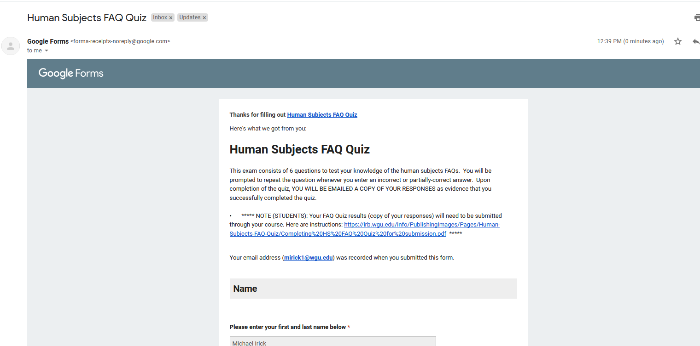

**APPENDIX B:** IRB approval (if applicable)